**Hydro master V3.2 Wiring and testing**

Table of Contents

**Parts list** 2

**Display** 4

**RTC** 4

**Relays** 5

**Dosers / Mosfets** 6

**PH & TDS Sensors** 7

**Co2 sensor** 8

**DHT22** 8

**DS18B20** 9

**Ultrasonic Distance Sensor** 9

**Etape 12” water level Sensor** 10

**LM317T 37V** **Regulator and ESP8266 Circuitry** 11

**ESP8266** 12

**Connecting the Nano(328p) to the Mega2560** 13

**MCP4151 Digital Potentiometer** 14

**Buzzer** 15

**RGB LED** 16

**Zero-point cross modules (Dual AC fans)** 16

# **Parts list**

To create the hydro controller please ensure you have the following components, note some parts are optional and are not required but will limit the functionality of the Hydro controller.

|  |  |
| --- | --- |
| **Part Name** | **Qty** |
| Arduino Mega Pro | 1 |
| Arduino Nano | 1 |
| 4 channel LLC | 3 |
| DS3231 RTC | 1 |
| JSN-SR04T waterproof distance sensor (if you’re not using the Etape) | 1 |
| Generic Chinese PH sensor | 1 |
| TDS Meter v1.0 | 1 |
| Etape 12” (if you’re not using the JSN-SR04T) | 1 |
| ESP8266-01 | 1 |
| MCP4151 10k Ω 256 steps | 1 |
| MH-Z14A Co2 sensor | 1 |
| DHT22 | 1 |
| DS18B20 Waterproof temperature sensor | 1 |
| Peristatic pump (5v to 36v) known as a doser pump | 6 |
| 8 channel relay board | 1 |
| BuyDisplay RA8875 TFT 800x480 SPI Display | 1 |
| 5 volt switching power supply 5 Amps+ | 1 |
| Zero Cross Module, 2 Channel (AC Light Dimmer module) | 1 |

|  |  |
| --- | --- |
| **Component Name** | **Qty** |
| MOSFET N-Channel 60V 55A TO220 STP55NF06L | 6 |
| Rectifier Diode 1A 50V 1.1Vf 30uA DO-41 | 6 |
| BC3375 800 mA, 45 V, 3-Pin TO-92 | 1 |
| 5v passive buzzer | 1 |
| 5V RGB LED 4-pins common anode | 1 |
| 8 pin DIL connector | 3 |
| 10Uf capacitors | 2 |
| 2-pin Non-Fused Terminal Block, 5.08mm Pitch | 6 |
| TE Connectivity 0Ω Through Hole Fixed Resistor | 4 |
| 36-way 1 row Straight 2.54 pitch Pin Header | 3 |
| Voltage regulator, LM317T 37V | 1 |
| 3266W top adj cermet trimmer,1K,6mm | 1 |
| PCB mount DC power socket 2.1mm 1A 12V | 1 |
| 1.8m Power Cable, 2.1 mm Plug Lead | 1 |
| Resistor, 0.25W ,5%, 220R | 8 |
| Resistor, 0.25W ,5%, 10k | 12 |
| Resistor, 0.25W ,5%, 430R | 1 |
| Resistor, 0.25W ,5%, 1k5 | 1 |
| Resistor, 0.25W ,5%, 560R | 1 |
| Resistor, 0.25W ,5%, 100R | 2 |
| Resistor, 0.25W ,5%, 4k7 | 2 |
| VP2106 MOSFET P-CH 0.25A -60V 3-Pin TO-92 | 3 |
| LP0701N3-G P-Channel Mosfet 1.5Amps | 1 |
| 2.54mm Pitch 40 Way 2 Row Straight PCB Socket | 4 |
| 2.54mm Pitch 36 Way 1 Row Straight PCB Socket | 3 |
| Female PCB spacer, M3, 12mm length | 12 |
| Female PCB spacer, M2.5, 12mm length0.7 | 4 |
| M3 screws | 24 |
| M2.5 screws | 8 |
| XHP Female Connector, 2.5mm Pitch, 3 Way, 1 Row | 1 |
| XH, B2B, 2 Way, 1 Row, Straight PCB Header | 1 |
| JST, XH Female Crimp Terminal Contact 22AWG | 3 |
| PS2505-2X AC Input NPN Phototransistor | 2 |
| Littelfuse 15A Fuse Holder, 32V dc | 1 |
| 40V 5A, Schottky Diode, DO-201AD | 1 |
| Marquardt DPST, Off-On Rocker Switch PCB | 1 |

**Mega 2560 Connections**

# **Display**

**Parts required:**

|  |  |
| --- | --- |
| **Part** | **Qty** |
| RA8875 800x480 resistive touch display | 1 |
| 8 channel high speed LLC, only required if 3.3v display | 1 |

**Connections:**

* JP1 pin 1 to mega GND
* JP1 pin 3 to mega 5v or 3.3 “depending on your display type, check data sheet”
* JP3 pin 11 to mega pin 32
* JP3 pin 10 to mega pin 2
* JP1 pin 5 to mega pin 34
* JP1 pin 6 to mega pin 50
* JP1 pin 7 to mega pin 51
* JP1 pin 8 to mega pin 52

**Note:** If you have a 3.3v display you will need to use a LLC, the hydro controller PCB has a header for a 8 channel LLC. If you are using a 5v display you will need to use a jumper in place of the LLC.

**Display spec sheet:** [**https://www.buydisplay.com/download/manual/ER-TFTM050-3_Datasheet.pdf**](https://www.buydisplay.com/download/manual/ER-TFTM050-3_Datasheet.pdf)

# **RTC**

Connect the following RTC pins to the Arduino Mega2560

**Parts required:**

|  |  |
| --- | --- |
| **Part** | **Qty** |
| DS3231 RTC clock module (i2c) | 1 |

**Connections:**

* GND to GND
* Vcc to 5v
* SDA to Mega pin 20 (SDA)
* SCL to Mega pin 21 (SCL)

# **Relays**

**Parts required:**

|  |  |
| --- | --- |
| **Part** | **Qty** |
| 8-channel relay module | 1 |

**Connections:**

* GND to GND
* Vcc to 5v
* Relay channel 1 to Mega pin 22
* Relay channel 2 to Mega pin 23
* Relay channel 3 to Mega pin 24
* Relay channel 4 to Mega pin 25
* Relay channel 5 to Mega pin 26
* Relay channel 6 to Mega pin 27
* Relay channel 7 to Mega pin 28
* Relay channel 8 to Mega pin 29

**Figure 1: 8-channel relay module**

# **Dosers / Mosfets**

**Parts required:**

|  |  |
| --- | --- |
| **Part** | **Qty** |
| 220 Ohms resistors | 4 to 6 depending on number of dosers you want |
| 10k Ohms resistors | 4 to 6 depending on number of dosers you want |
| MOSFET N-Channel 60V 55A TO220 STP55NF06L | 4 to 6 depending on number of dosers you want |
| Rectifier Diode 1A 50V 1.1Vf 30uA DO-41 | 4 to 6 depending on number of dosers you want |
| Peristatic pump 5 to 36v (doser) | 4 to 6 depending on number of dosers you want |
| LM2596S DC to DC Buck Converter | 1 |

**Connections:**

* Mosfet 1 gate to Mega pin 9
* Mosfet 2 gate to Mega pin 4
* Mosfet 3 gate to Mega pin 5
* Mosfet 4 gate to Mega pin 6
* Mosfet 5 gate to Mega pin 7 (optional doser)
* Mosfet 6 gate to Mega pin 8 (optional doser)
* 5v to LM2596S vcc input
* GNC to LM2596S gnd input
* LM2596S vcc output to doser vcc
* LM2596S gnd output to Mosfet source

**Figure 2: Mosfet circuitry to power the 4 dosers / peristatic pumps.**

# **PH & TDS Sensors**

**Parts required:**

|  |  |
| --- | --- |
| **Part** | **Qty** |
| 100 Ohms resistors 0.25 watts | 2 |
| PS2505-2X NPN Phototransistor | 2 |
| TDS Meter v1.0 sensor module | 1 |
| Generic Chinese PH module | 1 |

**Connections:**

* PH po pin (signal) to Analog pin A31
* PH PS2505 Digital input to pin D36
* GND to GND
* Vcc to 5v
* TDS signal to Analog pin A1
* PH PS2505 Digital input to pin D42
* GND to GND
* Vcc to 5v

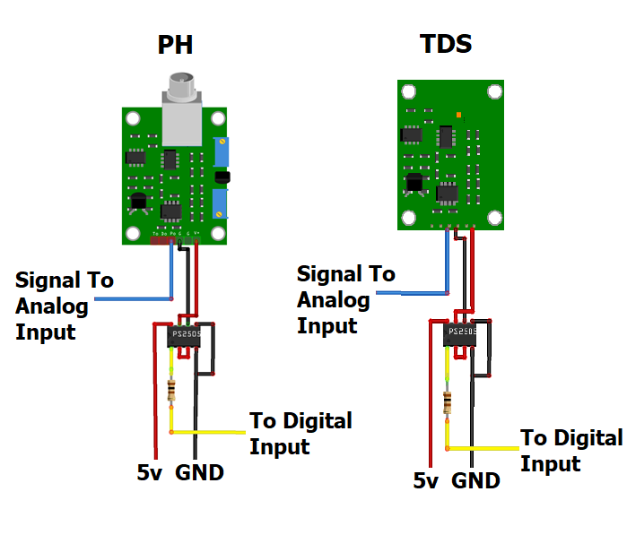**Figure 3: Circuitry to isolate and power the PH and TDS sensors**

# **Co2 sensor**

**Parts required:**

|  |  |
| --- | --- |
| **Part** | **Qty** |
| MH-Z14A Co2 sensor | 1 |

**Connections:**

* GND (Pin 16 on the Co2 board) to GND
* VCC (Pin 17 on the Co2 board) to 5v
* RX (Pin 18 on the Co2 board) Mega pin TX 1
* TX (Pin 19 on the Co2 board) Mega pin RX 1

# **DHT22**

**Parts required:**

|  |  |
| --- | --- |
| **Part** | **Qty** |
| DHT22 | 1 |
| 10k Ohm’s resistors | 1 |

**Connections:**

* VCC (DHT22 pin 1) to 5v
* Data (DHT22 pin 2) to Mega pin 39
* GND (DHT22 pin 4) to GND

**Figure 4: DHT22 wiring**

# **DS18B20**

**Parts required:**

|  |  |
| --- | --- |
| **Part** | **Qty** |
| DS18B20 | 1 |
| 4.7k Ohm’s resistors | 1 |

**Connections:**

* GND to GND
* Vcc to 5v
* Data to Mega pin 36

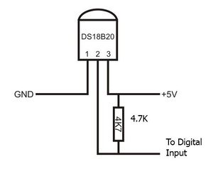

Figure 5: DS18B20 wiring.

# **Ultrasonic Distance Sensor**

**Parts required:**

|  |  |
| --- | --- |
| **Part** | **Qty** |
| JSN-SR04T Ultrasonic distance sensor | 1 |

**Connections:**

* GND to GND
* Vcc to 5v
* Trigger to Mega pin 37
* Echo to Mega pin 38

# **Etape 12” water level Sensor**

**Connections:**

* GND to GND
* Vcc to 5v
* Signal to A2

Figure 6: Etape 12” wiring.

# **LM317T 37V** **Regulator and ESP8266 Circuitry**

**Parts required:**

|  |  |
| --- | --- |
| **Part** | **Qty** |
| 10uF capacitors | 2 |
| Voltage regulator, LM317T 37V | 1 |
| 3266W top adj cermet trimmer,1K,6mm | 1 |
| 240 Omhs resistor 0.25 watts | 1 |
| BC3375 NPN transistor | 1 |
| LP0701N3-G P-Channel Mosfet 1.5Amps | 1 |
| 10K resistor 0.25 watts | 1 |
| 430 resistor 0.25 watts | 1 |
| 1.5k resistor 0.25 watts | 1 |
| 4-channel high sped LLLC | 1 |
| ESO8266-01 | 1 |

**Connections:**

* GND to GND
* Vcc to 5v
* 5v input to capacitor 1 positive
* GND to capacitor 1 negative
* 3.3v output to capacitor 2 positive
* GND to capacitor 2 negative

**Figure 7:** LM317T 37v power circuit and on off circuit for esp8266.

# **ESP8266**

**Connections:**

* GND to GND
* VCC the LM317T 3.3v output
* CH_PD the LM317T 3.3v output
* GPIO 0 the LM317T 3.3v output
* GPIO 2 the LM317T 3.3v output
* RX Mega pin TX 2
* TX Mega pin RX 2

Additionally: Please make sure you wire it correctly so that it is in boot mode 3, 7 for normal operation and 1,7 for programming, see the table below.

Note the ESP8266-01 does not have GPIO 15

|  |  |  |  |  |
| --- | --- | --- | --- | --- |
| **Number** | **GPIO 0** | **GPIO 2** | **GPIO 15** | **BOOT MODE** |
| **0** | **GND** | **GND** | **GND** | **NOT VALID** |
| **1** | **GND** | **3.3v** | **GND** | **UART** |
| **2** | **3.3v** | **GND** | **GND** | **NOT VALID** |
| **3** | **3.3v** | **3.3v** | **GND** | **FLASH** |
| **4** | **GND** | **GND** | **3.3v** | **SDIO** |
| **5** | **GND** | **3.3v** | **3.3v** | **SDIO** |
| **6** | **3.3v** | **GND** | **3.3v** | **SDIO** |
| **7** | **3.3v** | **3.3v** | **3.3v** | **SDIO** |

**Figure 8**: ESP8266-01 Boot Modes

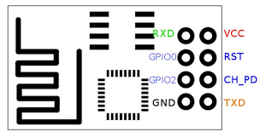

**Figure 9**: **ESP8266-01 pinout**

**Nano (328p) Connections**

# **Connecting the Nano(328p) to the Mega2560**

**Connections:**

* Nano 5v to 5v (do not use vin)
* Nano GND to Mega2560 GND
* Nano pin A4 to Mega2560 SDA (Mega2560 pin 20)
* Nano pin A5 to Mega2560 SCL (Mega2560 pin 21)

**Figure 10: Nano wiring**

# **MCP4151 Digital Potentiometer**

Note you should keep the 10k pot that you remove from the PH module so you can use it instead of the MCP4151 if you are unable to calibrate your PH module properly, the Hydro Master PCB has a DIP switch to swap between either the 10k pot or MCP4151.

**Parts required:**

|  |  |
| --- | --- |
| **Part** | **Qty** |
| MCP4151 10k digital pot 256 steps | 1 |

**Connections:**

* CS to nano pin 10
* SCLK to nano pin 13
* SDI/MOSI to nano pin 11
* VSS to GND
* PA0 to the input terminal of the potentiometer.
* PW0 to the output / wiper terminal of the potentiometer.
* PB0 to the GND terminal of the potentiometer.
* VCC to 5v

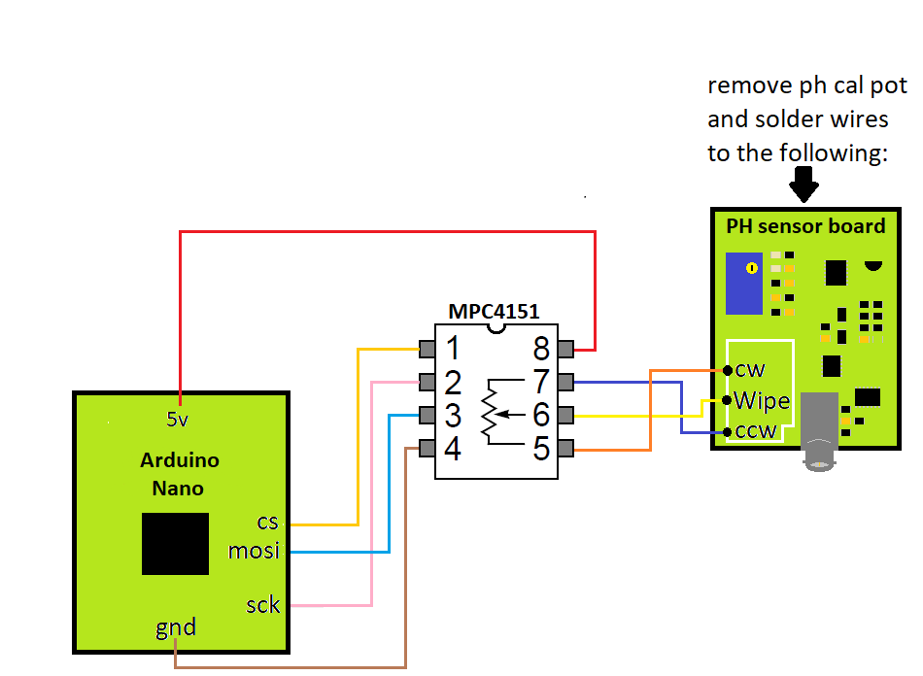

**Figure 11: MCP4151 wiring to the Arduino Nano**

# **Buzzer**

**Parts required:**

|  |  |
| --- | --- |
| **Part** | **Qty** |
| 5v passive buzzer | 1 |
| 100 Ohm resistor | 1 |

**Connections:**

* Buzzer Vcc to Nano pin 3 via a 100 Ohm resistor
* Buzzer GND to GND

# **RGB LED**

**Parts required:**

|  |  |
| --- | --- |
| **Part** | **Qty** |
| 5V RGB LED 4-pins common anode | 1 |
| ? Omhs resistor’s (depends on your led specs) | 3 |

**Connections:**

* LED Green to Nano pin 7
* LED RED to Nano pin 8
* LED Blue to Nano pin 9

Note:; For my Osram opto RGB LED I use (100 Ohms for blue, 240Omhs for red, 180 Ohms for green)

# **Zero-point cross modules (Dual AC fans)**

**Connections:**

* GND to GND
* Vcc to 5v
* AC Zero-point module interrupt Nano pin 2
* AC Zero-point module PWM one to Nano pin 4
* AC Zero-point module PWM two to Nano pin 5

**Note:** if you are using two single channelAC Zero-point modules one comment one of the interrupt pins on either of the modules to Nano pin 2.

**WARNING TAKE EXTRA CARE WHEN WIRING AC TO THE AC ZERO-POINT MODULE, MAKE SURE THE AC IS NOT LIVE WHEN WIRING AND WHEN LIVE MAKE SURE TO NOT TOUCH THE BOARD, AS LIVE COMPONENTS ARE EXPOSED !!!**

**I TAKE NO RESPONSIBILITY OF ANY KIND IN REGARD TO YOUR SAFTEY !!!**

**TESTING**

To test the wiring is correct a master test code is available, but please follow the steps below to ensure everything is setup to support the testing.

The Following test will not include the Wifi due to the fact it is limited to only those who have paid for Wifi support.

**Note: You should never try to power either of the Arduino’s from the USB alone when connected to the rest of the circuitry, especially the Arduino Nano, as the voltage regulator may burn out and could damage the rest of your components as some lack reverse polarity protection such as the RTC, so always power up the PCB with the 5v PSU before connecting any USBB cables.**

1. Before attempting to upload any code please make sure to install all the libraries in the libraries folder, and please note that the RA8875 library includes custom fonts and functions, so if you have existing versions please overwrite it with the one I have provided.
2. Power up the 5v switching power supply so that all the devices are active.
3. Connect the nano to your pc via USB and upload the Nanao_Slave_v2.0 code to the Arduino Nano, and then disconnect the nano USB cable.
4. Connect the mega to your pc via USB and upload the Mega2560_Master_test_code which is located in the example directory to the Arduino Mega2560.
5. Open the Serial monitor with the COM port set to the Arduino mega2560.
6. Type **?** into the Serial monitor and press enter, you will see a list in the serial monitor displaying the available test options, enter a given switch case command as shown in the output to test a device, in some cases you will have to wait for the test to complete before running the next test, I.E., the dosers and relay tests.
7. Once you have ran through all the tests and you are happy everything is working you can then upload the hydroControllerV3.2 to the mega2560.

Additionally, two other test codes are available in the example folder, one named DS3231_GetandSet_DateTime which is for the DS3231 and allows you to set the date and time quickly. The other example is named easyPaint and is a simple demo for the RA8875 display to test it on its own if you are having any difficulties.

* If you find that the display is blank when running easyPaint try pressing reset on the Arduino Mega, I have seen this happen of a few occasions as I think it loads the display before it is fully powered, the main test code and Hydro controller does not have this issue due to the time it takes to boot all the code and EEPROM ect...
* If you find that the touch is out of calibration you can calibrate the tft display using the tft_calibration example, then save the output to /RA8875/_utility/RA8875calibration.h